# Understanding basic network terms like IP, TCP/IP, DNS, DHCP, and more.

Questions;

## What is your public IP address right now, and how did you find it?

There are several ways to find your own public IP address.

One of the easier ways is to use a webpage that is made for it. Go to google and find the page named; “ip-lookup.net”.

You could also do it with the terminal:

Windows CMD; “nslookup myip.opendns.com resolver1.opendns.com”

Linux; “dig +short myip.opendns.com @resolver1.opendns.com”

**My current public IP is the following; “5.186.122.190”.**

That is at least for now, ever so often the public IP address changes for your devices that are connected to the internet. This is due to the way of how ISP’s(Internet Service Providers) use a DHCP(Dynamic Host Configuration Protocol) to assign IP addresses to your devices. Since we can’t make our ISP’s to keep the same address for us we have to use another “method”, in order to get a IP address that is the same. We can achieve this by using a “Dynamic DNS service”. This DNS will assign a name (URL) to your IP address while at the same time update it’s record of what your current IP address is. It does this each time your public address changes, effectively giving you one host name(URL).

As a last quick note.. One of multiple reasons that our IP addresses are dynamic is because it drastically improves security. If someone were to try and hack or otherwise attack your IP address, it will change with time, forcing you to change where the attack needs to be directed at.

– “This system is different if you have a fiber network connection” – Fiber netowk technically first gets a public ip when it connects to the web and not from the router in the house + the ip address doesn’t change every 14 days or so.

The router gives DHCP addresses for all local machines.

A server(Local NAS), or online server would be nice to have a static IP address. Always the same place to connect, but if not different it would open a lot more IP addresses for others to use.

## What is your private IP address right now (do this both at home and in school), and who/what gave you that address?

Yet again there are several ways to find your own private IP address.

The easiest way this time around would be by using the terminal.

Windows CMD; “ipconfig”

Linux; “ifconfig”

On windows you also could go through the following steps.

[Win-key] -> [Network status] -> [WiFi or Ethernet] -> [Hardware Properties]

**Home - My current private IP is the following; “192.168.1.175”.**

**School - My current private IP is the following; “”.**

Second part of the question is, “Who/What gave you the private IP address?

**The thing that provides us with a private IP address is our router**. The router redirects your devices request for an IP address to the correct DHCP(Dynamic Host Configuration Protocol) server. Then the DHCP server sends a package to your device with an offer. Then your device sends back a request to let the DHCP server know that you intend to use that IP address and then at last the DHCP server sends a Acknowledgement packet back confirming that your device has ben given a lease on the address for a server-specified period of time.

## What’s special about these address ranges?

All of the 3 ranges down below are private IP address ranges that don’t overlap.

(Don’t know if this is a satisfying answer)

* 10.0.0.0 – 10.255.255.255
* 172.16.0.0 – 172.31.255.255
* 192.168.0.0 – 192.168.255.255

## What’s special about this ip-address: 127.0.0.1?

**The address 127.0.0.1 is a special purpose IP address called “*localhost*” or “*loopback address*”.** It is a reserved IP address that all computer use as their own but it doesn’t let them communicate with other devices as a real IP address does.

Technically the entire range from 127.0.0.0 to 127.255.255.255 is reserved for loopback purposes, but you’ll almost never see anything but 127.0.0.1 used in the real world.

## What kind of service would you expect to find on a server using these ports: 22, 23, 25, 53, 80, 443?

* 22

SSH remote login protocol.

* 23

Telnet.

* 25

Simple mail transfer protocol.

* 53

Domain Name System (DNS)

* 80

HTTP

* 443

HTTPS

## What is the IP address of https://studypoints.info and how did you find it?

We can find the IP address in multiple ways again.

We can find the IP address by using a DNS lookup tool on the internet, we could use the tracert CMD function and we could ping the address from CMD.

I used mxtoolbox.com and their DNS lookup tool. There I typed in the URL from the question and got the result down below;

**Mxtoolbox.com; 157.230.21.145**

**Windows CMD; “tracert studypoints.dk” 157.230.21.145**

**Windows CMD; “ping www.studypoints.dk” 157.230.21.145**

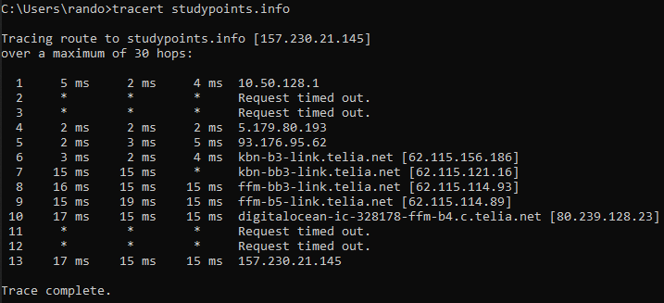

## If you write https://studypoints.dk in your browser, how did “it” figure out that it should go to the IP address you discovered above?

**The short answer is that the browser checks the cache for a DNS record to find the corresponding IP address of the URL typed into the search bar.**

To find the DNS record, the browser checks four caches;

First, it checks the browser cache. Second, the browser checks the OS cache. Third, it checks the router cache and fourth it checks the ISP’s own DNS cache.

If the ISP’s DNS cache doesn’t have the IP in their server, then they initiate a query to find the server that hosts the webpage(URL) in order to find the IP.

## Explain shortly the purpose of an ip-address and a port-number and why we need both

**To put it simply, IP addresses are to identify the hosts and port numbers are to identify/differentiate type of services on the hosts.** – If a port is a 433 we for example know that it needs to send the data to a browser.

## What is your (nearest) DNS server?

<http://www.whatsmydnsserver.com/>

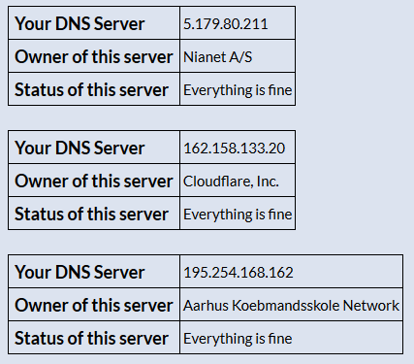

Not sure if I understand correctly but we could find the same settings from earlier to find this information.

[Win-key] -> [Network status] -> [WiFi or Ethernet] -> [Hardware Properties]

Home - Look for the; **“IPv4 DNS Servers: 192.168.1.254”**

Home - Windows CMD; “ipconfig /all” Look for DNS Servers – **“192.168.1.254”**

## What is (conceptually) the DNS system and the purpose with a DNS Server?

**What I believe a great analogy to a DNS system and Server would be like having a Phone book.**

**It is basically a big collection of names that are connecting numbers.**

## What is your current Gateway, and how did you find it?

Home - Windows CMD; “ipconfig” Look for Default Gateway – **“192.168.1.254”**

## What is the address of your current DHCP-Server, and how did you find it?

Dunno why all the addresses are the same.. DNS questions.

Home - Windows CMD; “ipconfig /all” Look for DHCP Server – **“192.168.1.254”**

## Explain (conceptually) about the TCP/IP-protocol stack

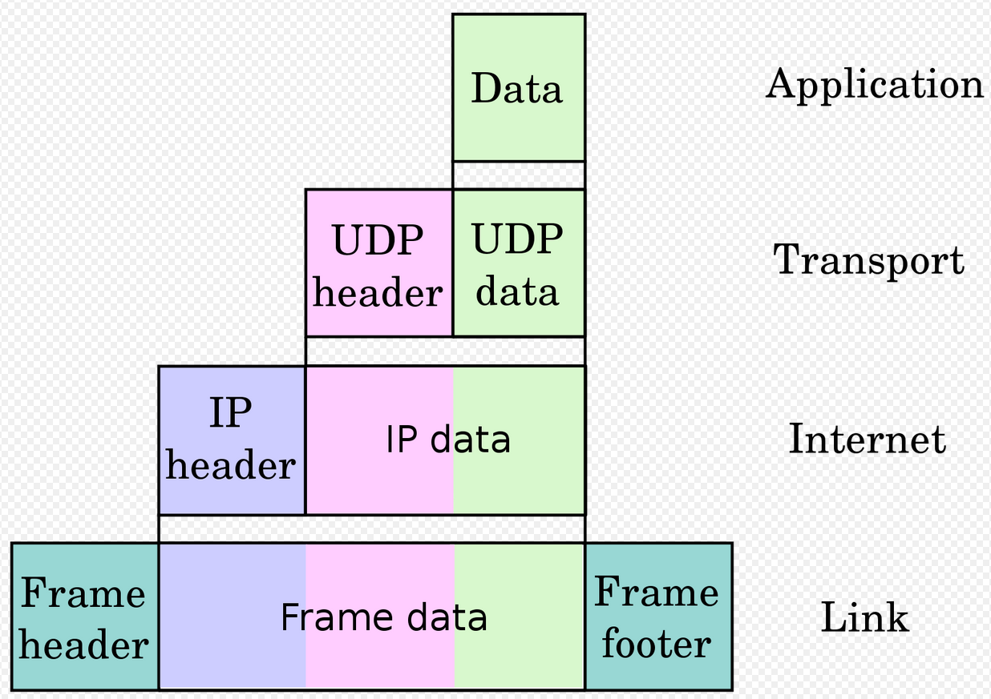

We start with the data from the application layer and build Transport layer on and Internet and at last we have a full Link (URL)

## Explain about the HTTP Protocol (the following exercises will go much deeper into this protocol)

(Hyper Text Transfer Protocol) HTTP.

An HTTP client sends a request message to an HTTP server. The server, in turn, returns a response message. In other words, HTTP is a pull protocol, the client pulls information from the server (instead of server pushes information down to the client).

## Explain (conceptually) how HTTP and TCP/IP are connected (what can HTTP do, and where does it fit into TCP/IP)

In the Internet part of the picture up above.